User Manual
For CS GradeBook

Prepared by
Pat Keller
Charles Missi

Table of Contents

Introduction ……………………………………………………………………………………………………………………………. 3

Section I: Student Use of CS GradeBook
Part A: Logging In ………………………………………………………………………………………………………… 3
Part B: Logging Out ……………………………………………………………………………………………………… 4
Part C: Submitting Assignments ……….…………………………………………………………………………. 4
Part D: Checking Submissions ……...……………………………………………………………………………… 8
Part E: Viewing Grades ……………...………………………………………………………………………………. 10

Section II: Course Staff Use of CS GradeBook
Part A: Logging In ………………………………………………………………………………………………………. 11
Part B: Logging Out ……………………………………………………………………………………………………. 12
Part C: Creating a New Assignment ……………………………………………………………………………. 13
Part D: Entering Grades ……………………………………………………………………………………………… 15

Section III: System Administrator Use of CS GradeBook
Part A: View Staff Log ………………………………………………………………………………………………… 16
Part B: View Student Log …………………………………………………………………………………………… 16
Part C: View Error Log ………………………………………………………………………………………………… 17

Introduction
This user manual describes use and management of the CS GradeBook application. It is mainly a how-to guide for using all the features of the CS GradeBook, but it also contains some information intended for system administrators. The application is broken down into a student side and a course staff side, both of which are accessed via the Login Page.

Section I: Student Use of CS GradeBook

Part A: Logging In
To log in, first navigate to the CS GradeBook using your web browser. Input your CS username and password into their respective fields and click the “Login” link. If your input was correct, you will be directed to the student homepage.
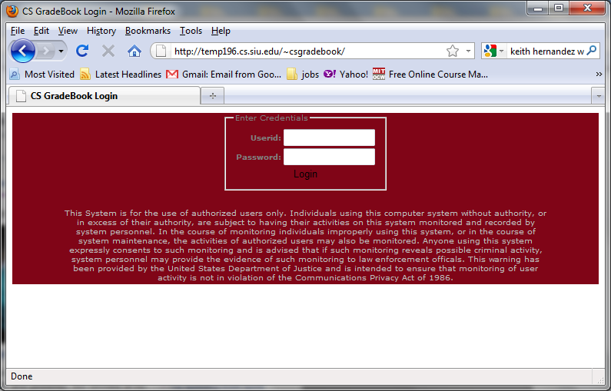

Part B: Logging Out
To log out, click the “Logout” link on the left side of any student page. Clicking this link will destroy all session variables, log your account out of the CS GradeBook, and direct you back to the login page.
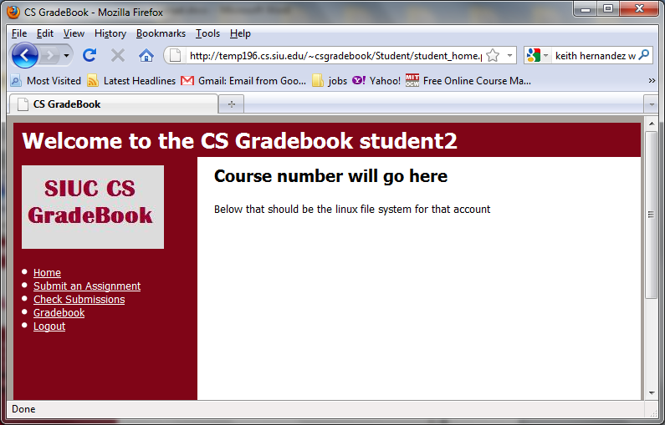

Part C: Submitting Assignments
- Click the “Submit an Assignment” link on the left side of any student page. This will direct you to a page where you select which class you want to submit to from a drop down menu.
- Select your class and click the “Submit” button. This will direct you to a page where you can choose which assignment you want to submit to from a drop down menu.
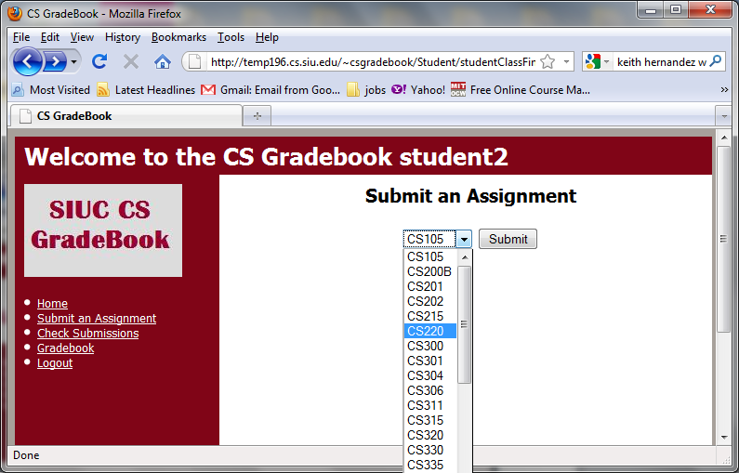
- Select your assignment and click the “Submit” button. This will direct you to a page where you choose your files to upload.
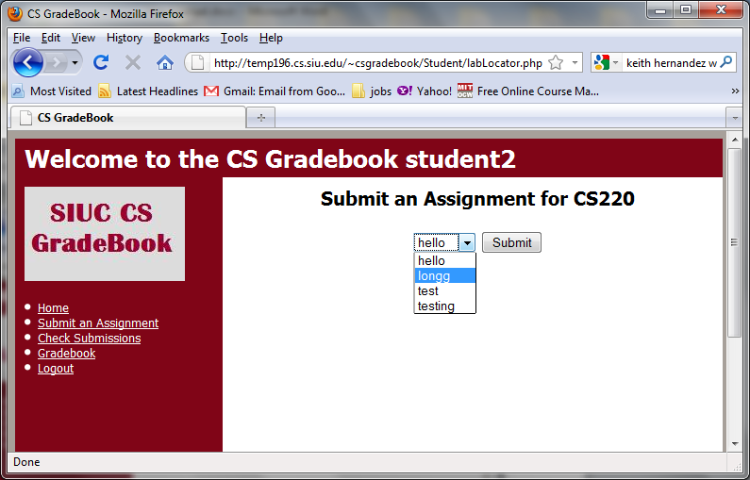

- Click the “Browse” button, and choose your file to upload. Click the “Add” button. The file name should now appear in a table with a check box next to the name.
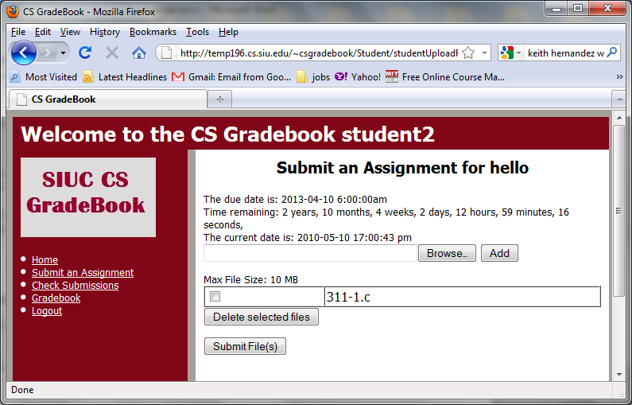
- Continue adding files until you have all of the files for your assignment in the table.
- If you select the wrong file for upload, you may delete it from the table by checking the check box and clicking the “Delete selected files” button.
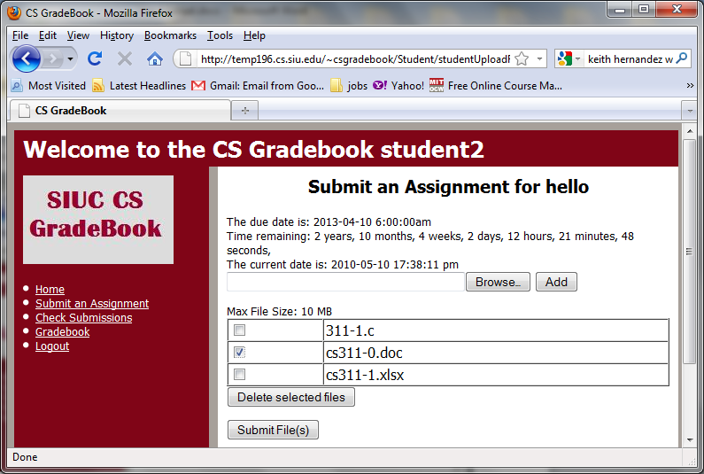
- Once all of the correct files have been selected, click the “Submit File(s)” button.
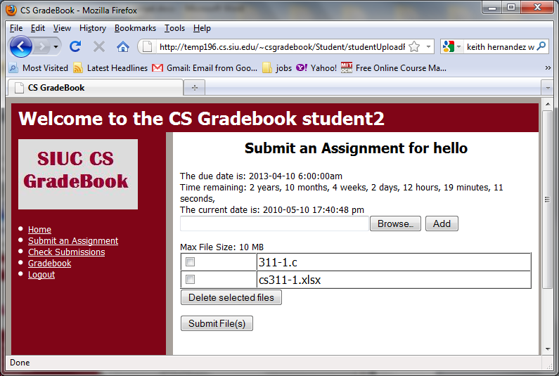
- Your files have now been uploaded to the assignment directory.

Part D: Checking Submissions
- Click the “Check Submissions” link on the left side of any student page. This will direct you to a page where you select from a drop down menu, which class you want to view your submissions to.
- Select your class and click the “Submit” button. This will direct you to a page where you can choose from a drop down menu which assignment you want to view your submissions to.
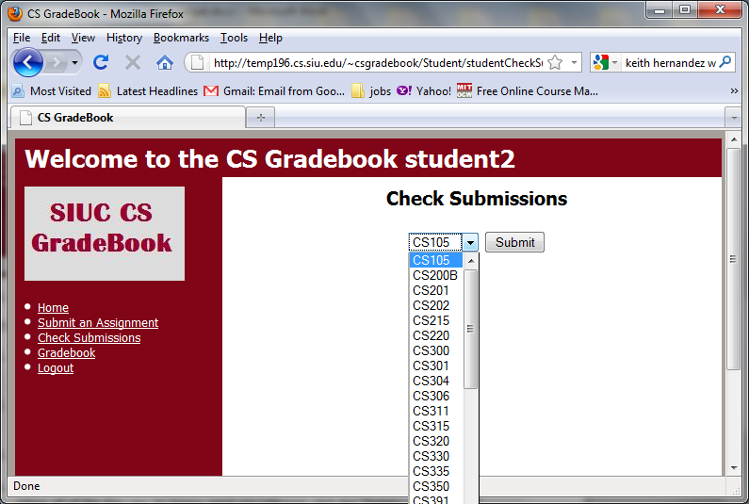
- Select your assignment and click the “Submit” button. This will direct you to a page where you can view all of the files you have previously uploaded.
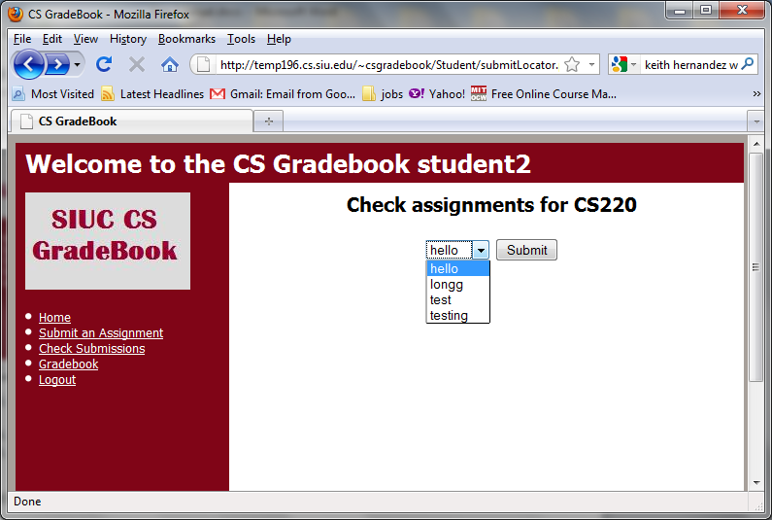
- If you wish to delete files, select the checkbox to the left of the files you wish to delete.
- When all of the files you no longer need are selected, click the “Delete selected files” button.
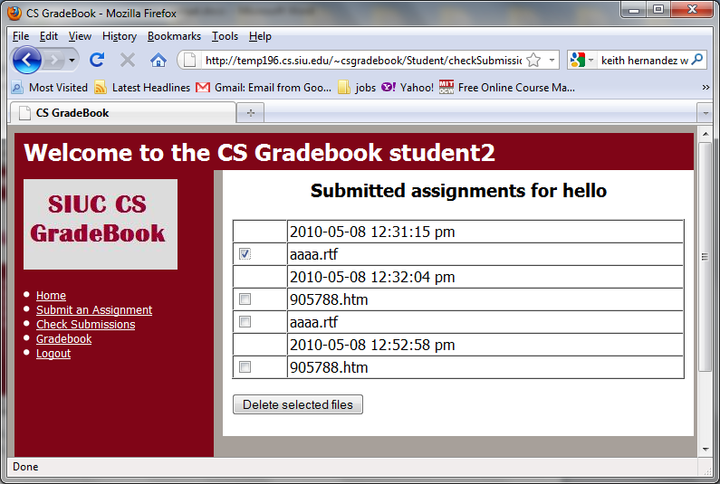
Part E: Viewing Grades
- Click the “Gradebook” link on the left side of any student page. This will direct you to a page where you select from a drop down menu, which class you want to view your grades for.
- Select your class and click the “Submit” button. This will direct you to a page where you can see each assignment for the class, and the grade you received on that assignment.
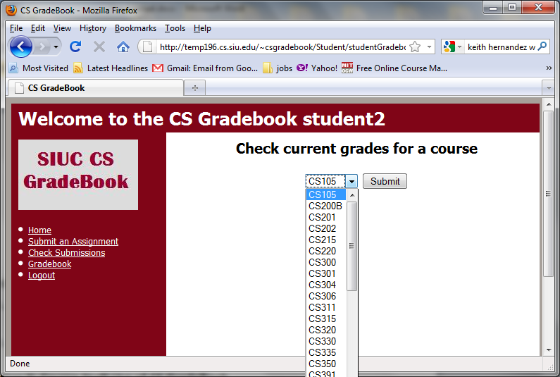
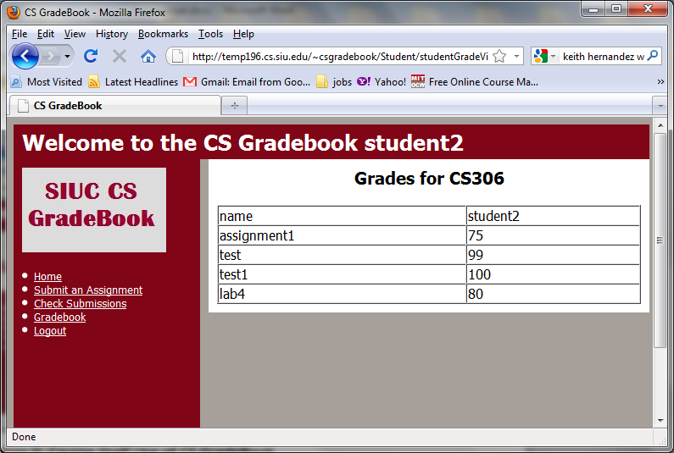
Section II: Course Staff Use of CS GradeBook
Part A: Logging In
To log in, first navigate to the CS GradeBook using your web browser. Input your course account username (ex. cs306) and password into their respective fields and click the “Login” link. If your input was correct, you will be directed to the staff homepage.
Part B: Logging Out
To log out, click the “Logout” link on the left side of any staff page. Clicking this link will destroy all session variables, log your account out of the CS GradeBook, and direct you back to the login page.

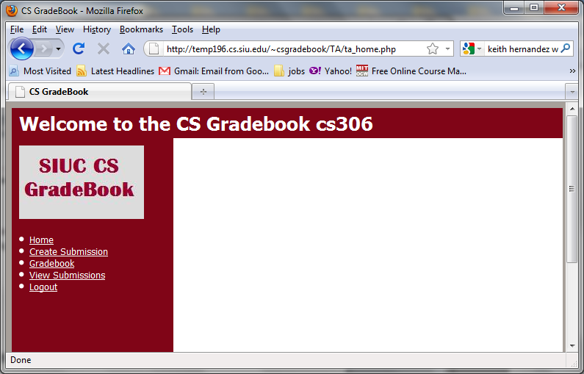

Part C: Creating a New Assignment
- Click the “Create Submission” link from the left side of any staff page. This will direct you to a page where you can enter the information for the assignment you wish to create.

- Enter all of the information for the assignment, i.e. Name, due date, and time due. When all of the information has been specified, click the “Submit” button. A new assignment directory will be created, a new column is added to the grades file, and the due date is stored in a text file.
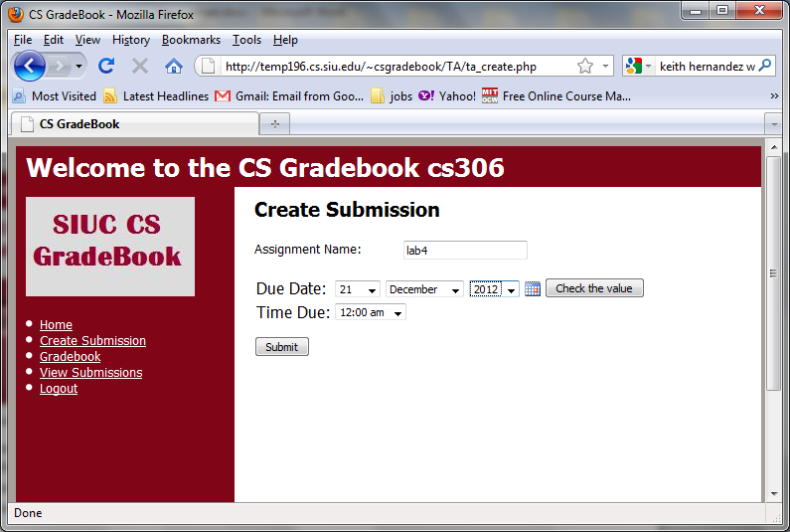

Part D: Entering Grades
- Click the “Gradebook” link on the left side of any staff page. This will direct you to a page where you select the assignment to enter grades for.
- Select the assignment you wish to enter grades for from the drop down menu. When the correct assignment has been selected, click the “Submit” button.
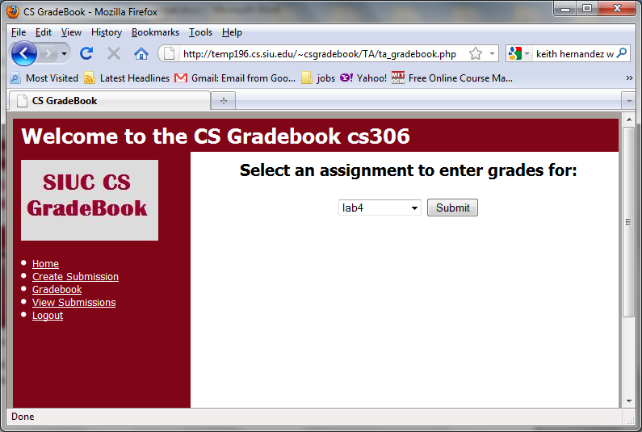
- Enter the appropriate grades for the selected assignment. Once all of the grade fields have the correct grades, click the “Submit” button. This will save the entered grades to the grades file.
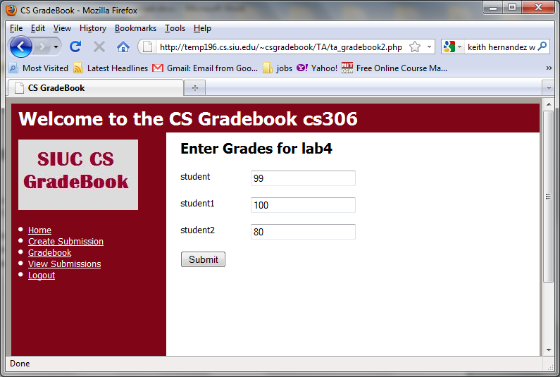
Part E: Viewing Submissions

Section III: System Administrator Use of CS GradeBook
Part A: Viewing the Staff Log
Beneath the “TA” directory, there will be a file “ta_log.txt”. Any actions that a course staff member takes while logged into the system will be recorded here. This includes when the user logs in, new assignments are created, grades are entered or changed, and when the user logs out.
Part B: Viewing the Student Log
Beneath the “Student” directory, there will be a file “student_log.txt”. Any actions that a student takes while logged into the system will be recorded here. This includes when the user logs in, submits files to assignments, deletes files from their previous submissions, and when the user logs out.

Part C: Viewing the Error Log
Beneath the “public_html” directory, there will be a file “error_log.txt”. Any time someone tries to navigate to a page when not authenticated, they will be redirected to the log in page; their IP address and the time are logged. Any time a logged in user tries to access a page they should not, such as a student trying to navigate to a staff page, the student’s username, IP address, and the time will be logged.

